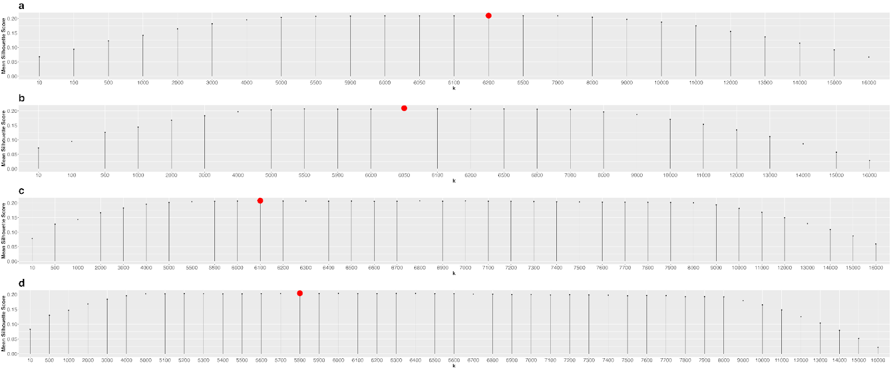

Supplementary Figure S3: Average Silhouette Score vs Number of clusters (K) used in K-means. a. ADA-002 when WHO system all editions terms are used. b. ADA-002 when WHO system 5th edition terms are used c. LTE-3 when WHO system all editions terms are used d. LTE-3 when WHO system 5th editions terms are used.

